06 JUNI 2023

FUNCTIONAL SPESIFICATION DESIGN

APLIKASI DEPOSITO SYARIAH   
BPRS HARTA INSAN KARIMAH

PT. DATA SAINS INTEKNOVA

EAST SQUARE BUSINESS CENTRE

Jl. Pemuda No. 65 Rawamangun Jakarta Timur 13220

Telp: 021-82740286

Dokumen ini disiapkan dan diawasi oleh:



# PT. DATA SAINS INTEKNOVA

East Square Business Centre Jl. Pemuda No. 65 Rawamangun Jakarta Timur 13220 – Indonesia

# FUNCTIONAL SPESIFICATION DESIGN

Aplikasi Deposito Syariah

Nomor Dokumen: PDC/SIM/VII-23/001 Disiapkan untuk:



# BPRS HARTA INSAN KARIMAH

Jl. Dr. Suratmo No. 318  
Semarang, Jawa Tengah – Indonesia

2023

**LEMBAR PERSETUJUAN**

Dokumen ini telah disetujui bersama oleh:

|  |  |  |  |  |
| --- | --- | --- | --- | --- |
| No | Nama | Posisi | Perusahaan | TTD |
|  |  |  |  |  |
|  |  |  |  |  |
|  |  |  |  |  |
|  |  |  |  |  |
|  |  |  |  |  |
|  |  |  |  |  |
|  |  |  |  |  |

Dokumen ini menjadi acuan dalam pengembangan aplikasi Deposito Syariah di   
BPRS HARTA INSAN KARIMAH

**DAFTAR ISI**

1. Struktur Database 5

a. Database Utama 5

b. Database Transaksi 6

c. Database Customer Service 6

d. Database Enkriptor 6

2. Bisnis Proses Aplikasi Deposito Syariah 7

a. Registrasi Nasabah 7

b. Registrasi Admin Mitra dan Staff Mitra 7

c. Pembelian dan Validasi 8

d. Penarikan Dana dan Validasi 8

e. Penanganan Komplain 9

f. Updating Splash Screen 9

g. Updating Promo Mitra BPR 10

h. Updating Tenor 10

i. Updating Bagi Hasil 11

j. Updating Penalti 11

3. Tampilan Login Page 12

4. Tampilan Register Mitra Page 13

5. Tampilan Register Nasabah Page 13

6. Tampilan Validasi Mitra BPR 15

7. Tampilan Validasi Nasabah 16

8. Tampilan Tambah Produk Deposito 17

9. Tampilan Daftar Deposito 17

10. Tampilan Pengajuan Pembelian 18

11. Tampilan Pengajuan Penarikan 19

12. Tampilan Validasi Pengajuan Pembelian 20

13. Tampilan Validasi Pembayaran WD 21

14. Tampilan Validasi Penarikan Dana Deposito 21

15. Tampilan Detail Nasabah 22

16. Tampilan Detail Mitra BPR 22

17. Tampilan Dashboard Nasabah 23

18. Tampilan Dashboard Mitra 23

19. Tampilan Log / Notifikasi Mitra dan Nasabah 24

20. Tampilan Portal Web 25

21. Tampilan Customer Service 26

22. Tampilan Kriptor Engine, Monitoring Services, dan Database 27

# Struktur Database

Aplikasi ini akan dibangun dengan teknis mirroring Database, yang bertujuan apabila Database mengalami gangguan, maka Database cadangan akan difungsikan.

Berikut struktur Database pada aplikasi ini

## Database Utama

Database ini berisikan data-data Mitra BPR, Nasabah, dan User-user yang bertugas sebagai Admin Aplikasi. Berikut strukturnya.

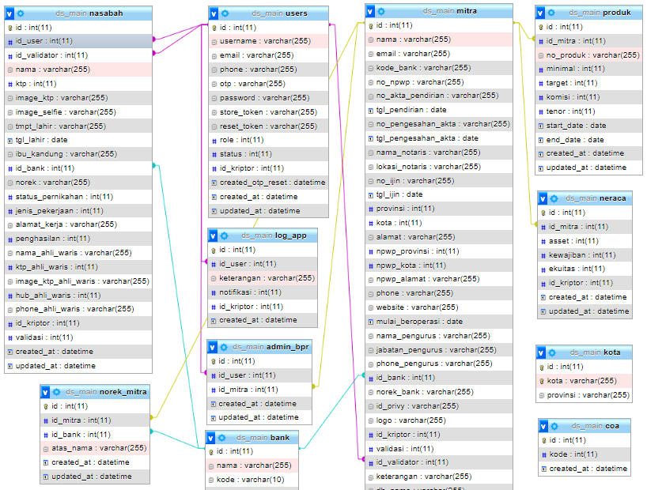

## Database Transaksi

Database ini berisikan data transaksi tiap mitra dan data rekap tiap bulan agar kalkulasi transaksi dapat dilakukan dengan lebih cepat.

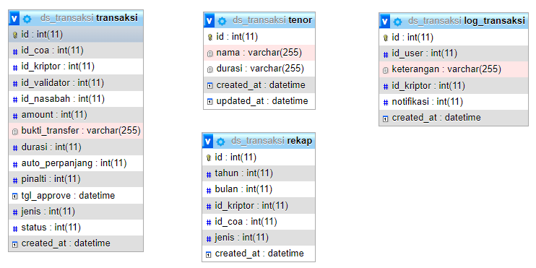

## Database Customer Service

Database ini berisikan data komplain nasabah, voice record, chat, dan penilaian layanan.

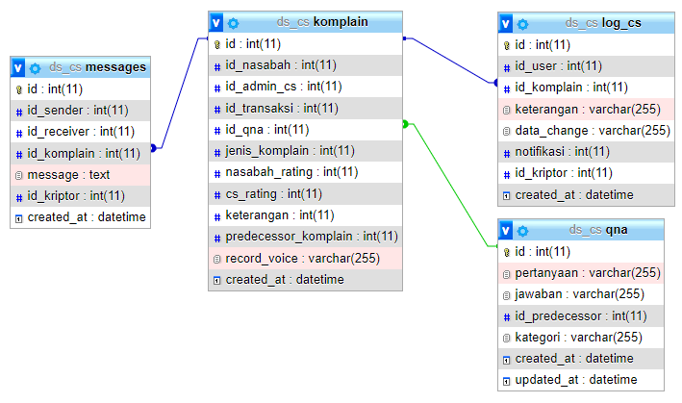

## Database Enkriptor

Database ini berisikan kode untuk enkripsi data.

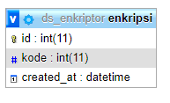

# Bisnis Proses Aplikasi Deposito Syariah

## Registrasi Nasabah dan Mitra BPR

Berikut gambaran Bisnis proses untuk Registrasi Nasabah dan Mitra BPR.

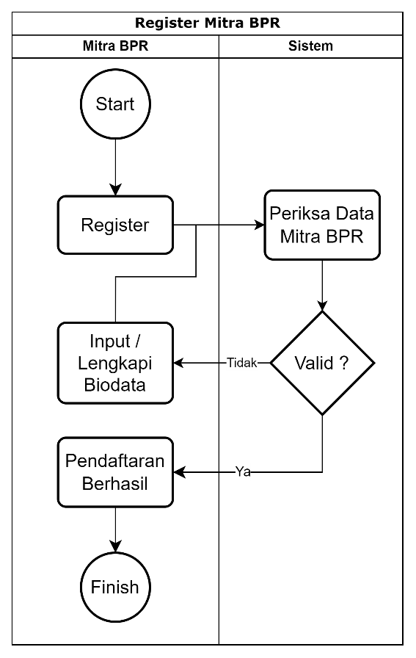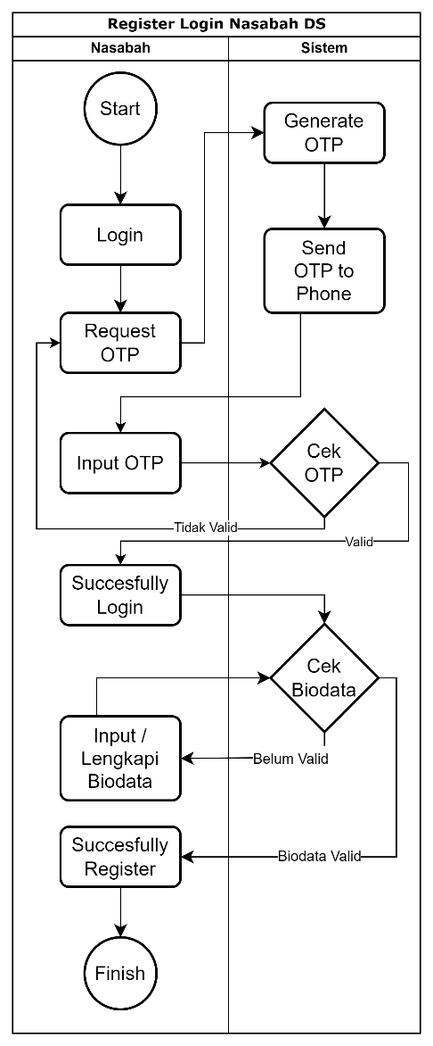

## Registrasi Admin Mitra dan Staff Mitra

Berikut gambaran Bisnis proses untuk Registrasi Admin Mitra dan Staff Mitra.

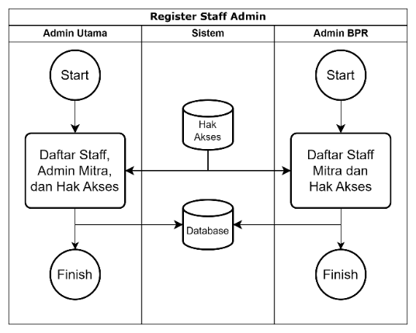

## Pembelian dan Validasi

Berikut gambaran Bisnis proses untuk Pembelian dan Validasi.

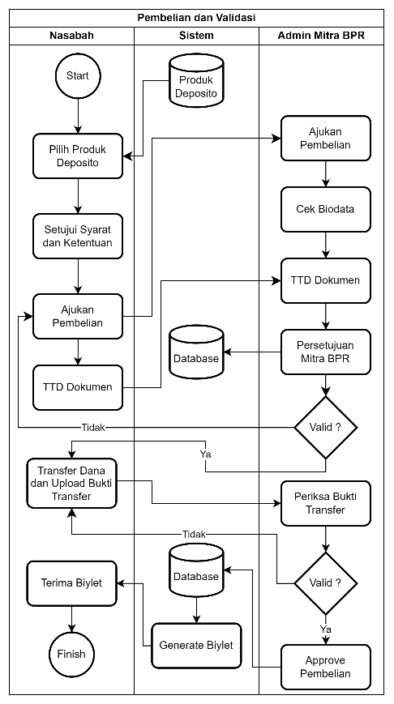

## Penarikan Dana dan Validasi

Berikut gambaran Bisnis proses untuk Penarikan Dana, Pengembalian Dana, Bagi Hasil dan Validasinya.

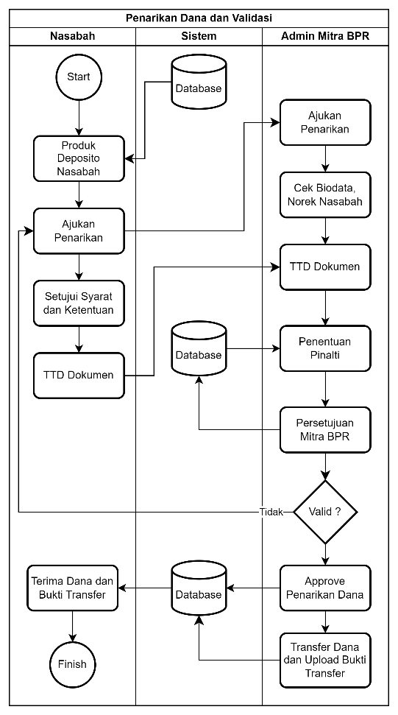 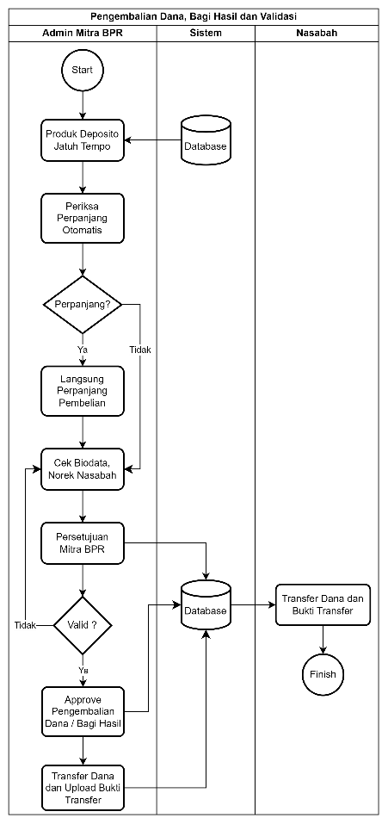

## Penanganan Komplain

Berikut gambaran Bisnis proses untuk Penanganan Komplain.

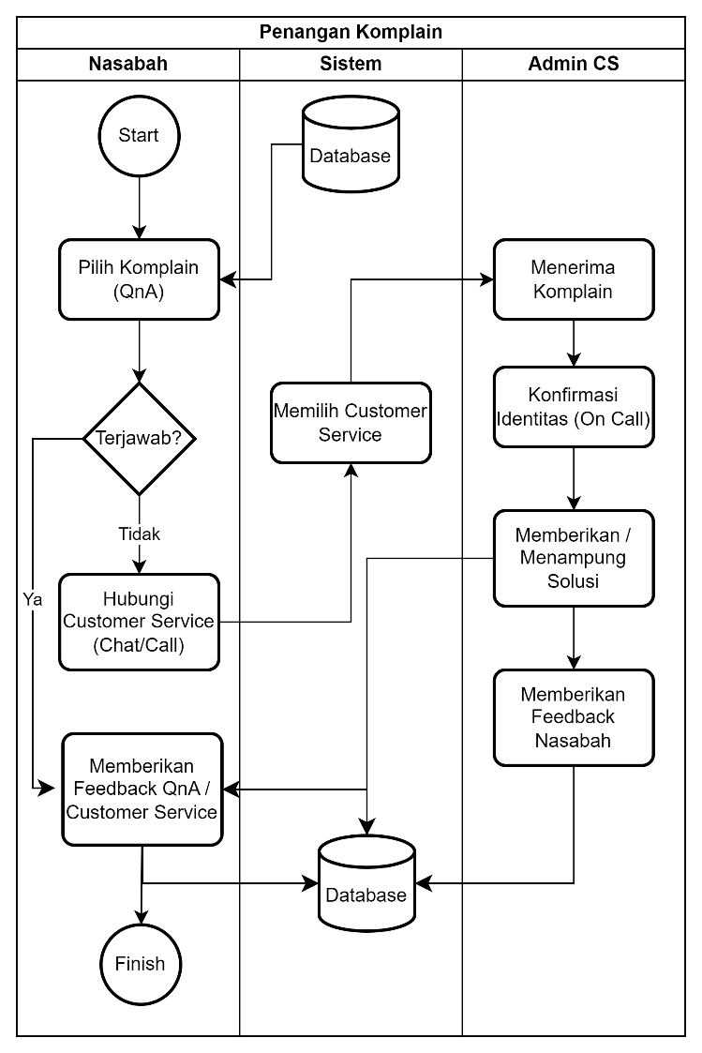

## Updating Splash Screen

Berikut gambaran Bisnis proses untuk Penambahan atau edit Splah Screen.

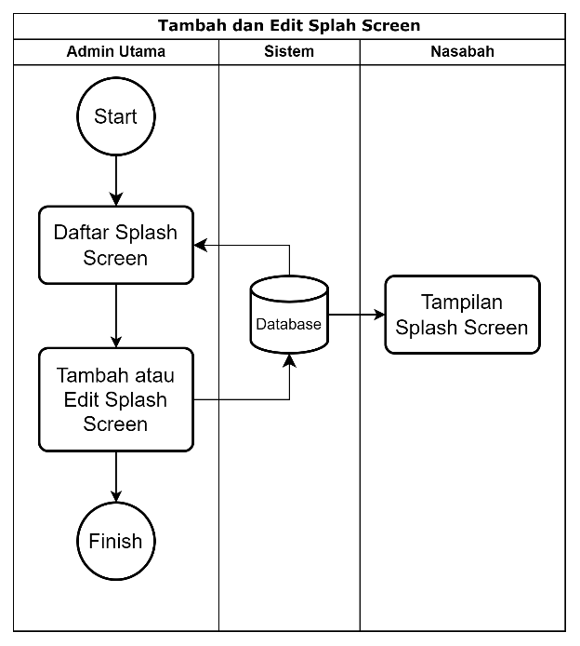

## Updating Promo Mitra BPR

Berikut gambaran Bisnis proses untuk Penambahan atau edit Promo Mitra BPR.

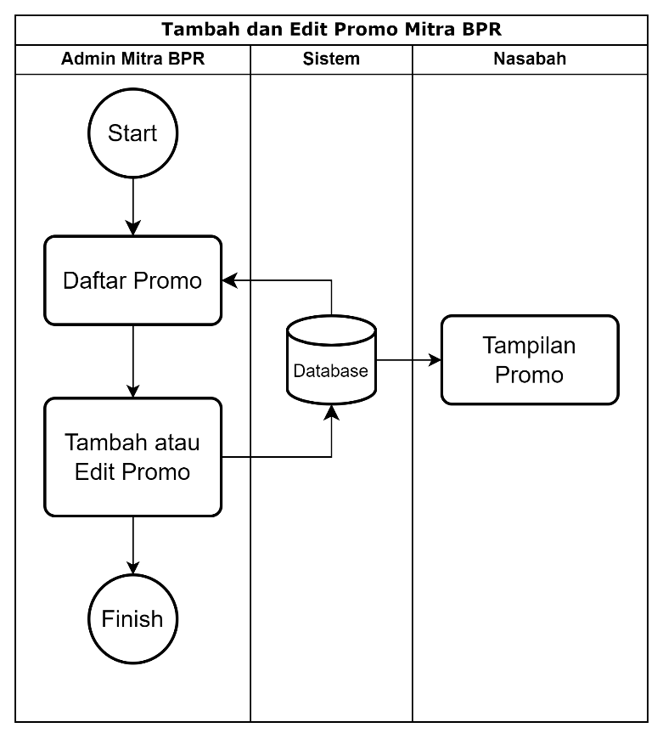

## Updating Tenor

Berikut gambaran Bisnis proses untuk Penambahan atau edit Tenor.

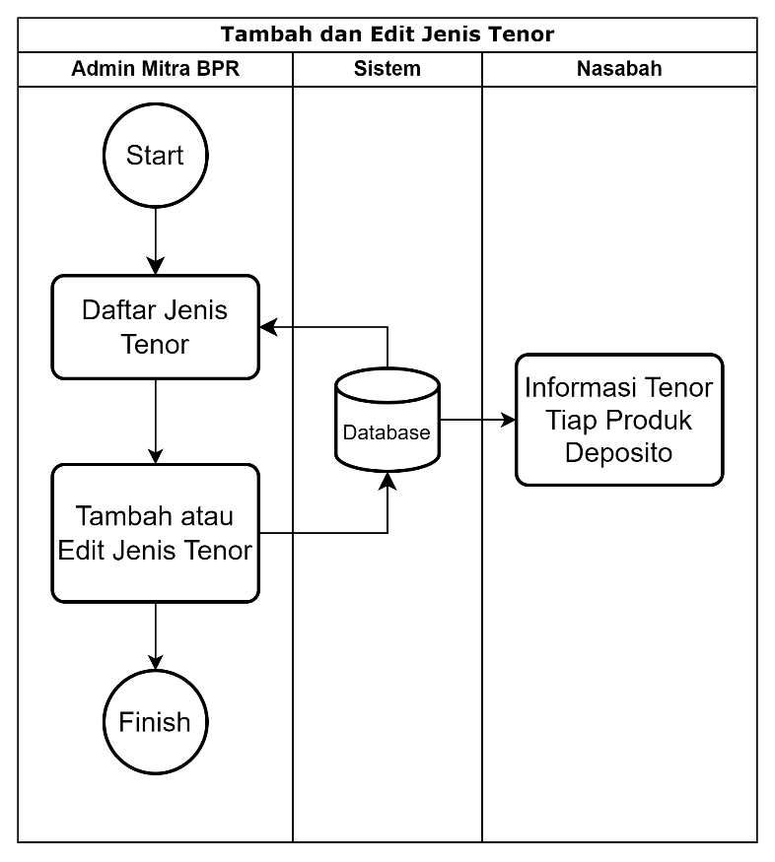

## Updating Bagi Hasil

Berikut gambaran Bisnis proses untuk Penambahan atau edit Bagi Hasil.

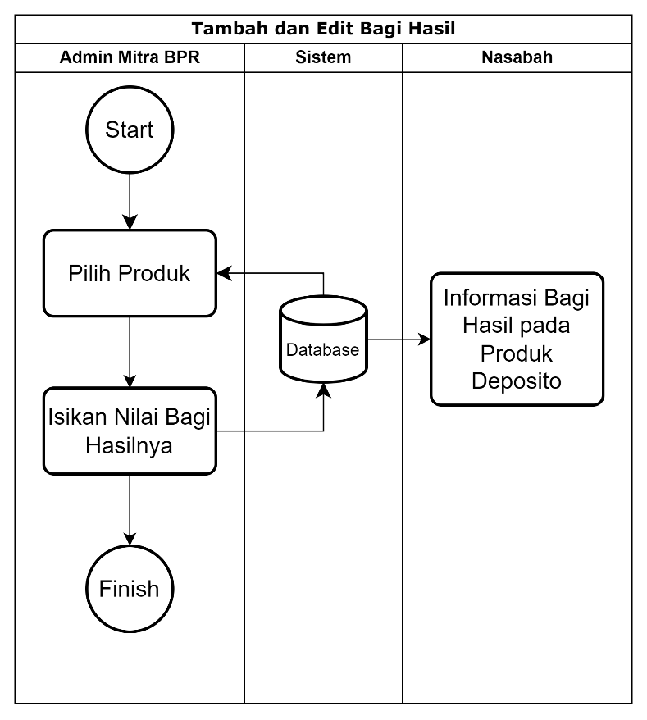

## Pemberian Penalti (Optional)

Berikut gambaran Bisnis proses untuk Pemberian Pinalti.

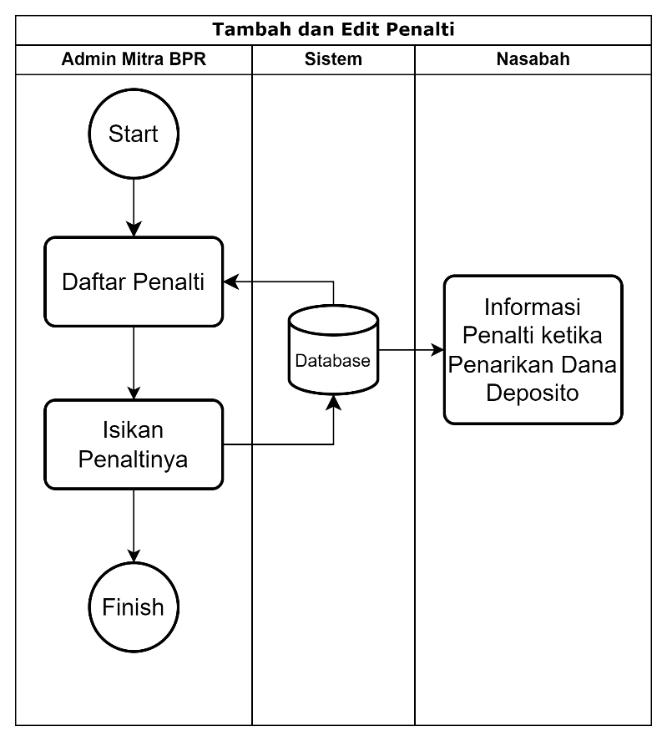

# Tampilan Login Page

Halaman ini melakukan login untuk semua pengguna ke aplikasi Deposito Syariah pada website dan aplikasi mobile.

|  |  |  |  |  |  |  |  |  |  |  |  |  |  |  |  |  |  |  |  |  |  |  |  |  |  |  |
| --- | --- | --- | --- | --- | --- | --- | --- | --- | --- | --- | --- | --- | --- | --- | --- | --- | --- | --- | --- | --- | --- | --- | --- | --- | --- | --- |
| |  |  |  |  |  |  |  |  |  |  |  |  |  |  |  |  |  |  |  |  |  |  |  |  |  |  | | --- | --- | --- | --- | --- | --- | --- | --- | --- | --- | --- | --- | --- | --- | --- | --- | --- | --- | --- | --- | --- | --- | --- | --- | --- | --- | | Login   |  | | --- | | Username / Phone | |  | |  | |  | |  | |  | | Next | |  | Login   |  | | --- | | Insert OTP | |  | |  | |  | | Resend OTP in 5 minutes | |  | | Login | |  | Login   |  | | --- | | Insert Password | |  | |  | |  | | Forgot password ? | |  | | Login | | |

Dari halaman ini user nantinya bisa diberikan akses sesuai dengan role masing-masing user.

Untuk admin login menggunakan username / email, sedangkan nasabah login menggunakan no selular.

# Tampilan Register Mitra BPR

Halaman ini digunakan untuk pendaftaran sebagai Mitra di aplikasi Deposito Syariah pada website dan aplikasi mobile. Berikut Tampilannya

|  |  |  |  |  |  |  |  |  |  |  |  |  |  |  |  |  |  |  |  |  |  |  |  |  |  |  |  |  |  |  |  |  |  |  |  |  |  |  |  |  |  |  |  |  |  |  |  |  |  |  |  |  |  |  |  |  |  |  |  |  |  |  |  |  |  |  |  |  |  |  |  |  |  |  |  |  |  |  |  |  |  |  |  |  |  |  |  |  |  |  |  |  |  |  |  |  |  |  |  |  |  |  |  |  |  |  |
| --- | --- | --- | --- | --- | --- | --- | --- | --- | --- | --- | --- | --- | --- | --- | --- | --- | --- | --- | --- | --- | --- | --- | --- | --- | --- | --- | --- | --- | --- | --- | --- | --- | --- | --- | --- | --- | --- | --- | --- | --- | --- | --- | --- | --- | --- | --- | --- | --- | --- | --- | --- | --- | --- | --- | --- | --- | --- | --- | --- | --- | --- | --- | --- | --- | --- | --- | --- | --- | --- | --- | --- | --- | --- | --- | --- | --- | --- | --- | --- | --- | --- | --- | --- | --- | --- | --- | --- | --- | --- | --- | --- | --- | --- | --- | --- | --- | --- | --- | --- | --- | --- | --- | --- | --- | --- | --- |
| |  |  |  |  |  |  |  |  |  |  |  |  |  |  |  |  |  |  |  |  |  |  |  |  |  |  |  |  |  |  |  |  |  |  |  |  |  |  |  |  |  |  |  |  |  |  |  |  |  |  |  |  |  |  |  |  |  |  |  |  |  |  |  |  |  |  |  |  |  |  |  |  |  |  |  |  |  |  |  |  |  |  |  |  |  |  |  |  |  |  |  |  |  |  |  |  |  |  |  |  |  |  |  |  |  |  | | --- | --- | --- | --- | --- | --- | --- | --- | --- | --- | --- | --- | --- | --- | --- | --- | --- | --- | --- | --- | --- | --- | --- | --- | --- | --- | --- | --- | --- | --- | --- | --- | --- | --- | --- | --- | --- | --- | --- | --- | --- | --- | --- | --- | --- | --- | --- | --- | --- | --- | --- | --- | --- | --- | --- | --- | --- | --- | --- | --- | --- | --- | --- | --- | --- | --- | --- | --- | --- | --- | --- | --- | --- | --- | --- | --- | --- | --- | --- | --- | --- | --- | --- | --- | --- | --- | --- | --- | --- | --- | --- | --- | --- | --- | --- | --- | --- | --- | --- | --- | --- | --- | --- | --- | --- | --- | | Registrasi Mitra BPR   |  |  |  | | --- | --- | --- | | **Identitas BPR** | | | | Nama BPR | : |  | | Email | : |  | | Kode Bank | : |  | | Phone | : |  | | Website | : |  | | Mulai Beroperasi | : |  | | Alamat BPR | : |  | | Provinsi BPR | : |  | | Kota BPR | : |  | | **NPWP BPR** |  |  | | No NPWP BPR | : |  | | Alamat NPWP | : |  | | Provinsi NPWP | : |  | | Kota NPWP | : |  | | No Akta Pendirian | : |  | | **Akta Pendirian** |  |  | | No Pengesahan Akta Pendirian | : |  | | Tanggal Pengesahan Akta Pendirian | : |  | | Nama Notaris | : |  | | Alamat Notaris | : |  | | No Ijin Notaris | : |  | | Tanggal Ijin Notaris | : |  | | **Pengurus** |  |  | | Jabatan Pengurus | : |  | | Phone Pengurus | : |  | | **Data Bank** |  |  | | Norek Bank | : |  | | Nama Bank |  |  | | **TTD Digital** |  |  | | Apakah memiliki akun PrivyID? | : | Ya / Tidak, Isi ID PrivyID | | **LOGO BPR** |  |  | | Logo BPR | : | Pilih File | |  |  |  | |  |  | SUBMIT | | |

# Tampilan Register Nasabah Page

Halaman ini digunakan untuk pendaftaran sebagai Nasabah di aplikasi Deposito Syariah pada website dan aplikasi mobile. Berikut Tampilannya

|  |  |  |  |  |  |  |  |  |  |  |  |  |  |  |  |  |  |  |  |  |  |  |  |  |  |  |  |  |  |  |  |  |  |  |  |  |  |  |  |  |  |  |  |  |  |  |  |  |  |  |  |  |  |  |  |  |  |  |  |  |  |  |  |  |  |
| --- | --- | --- | --- | --- | --- | --- | --- | --- | --- | --- | --- | --- | --- | --- | --- | --- | --- | --- | --- | --- | --- | --- | --- | --- | --- | --- | --- | --- | --- | --- | --- | --- | --- | --- | --- | --- | --- | --- | --- | --- | --- | --- | --- | --- | --- | --- | --- | --- | --- | --- | --- | --- | --- | --- | --- | --- | --- | --- | --- | --- | --- | --- | --- | --- | --- |
| |  |  |  |  |  |  |  |  |  |  |  |  |  |  |  |  |  |  |  |  |  |  |  |  |  |  |  |  |  |  |  |  |  |  |  |  |  |  |  |  |  |  |  |  |  |  |  |  |  |  |  |  |  |  |  |  |  |  |  |  |  |  |  |  |  | | --- | --- | --- | --- | --- | --- | --- | --- | --- | --- | --- | --- | --- | --- | --- | --- | --- | --- | --- | --- | --- | --- | --- | --- | --- | --- | --- | --- | --- | --- | --- | --- | --- | --- | --- | --- | --- | --- | --- | --- | --- | --- | --- | --- | --- | --- | --- | --- | --- | --- | --- | --- | --- | --- | --- | --- | --- | --- | --- | --- | --- | --- | --- | --- | --- | | Registrasi Nasabah   |  |  | | --- | --- | | **Identitas** |  | | Nama Lengkap Sesuai KTP |  | | Email |  | | Phone |  | | Alamat Sekarang |  | |  |  | | **Detail** |  | | No KTP |  | | Tempat Lahir |  | | Tanggal Lahir |  | | Nama Ibu Kandung tanpa Gelar |  | | Status Pernikahan |  | | Jenis Pekerjaan |  | | Alamat Pekerjaan |  | | Penghasilan |  | |  |  | | **Rekening Nasabah** |  | | Nama Bank |  | | No Rekening |  | | Atas Nama Rekening |  | |  |  | | **Ahli Waris** |  | | Nama Ahli Waris |  | | No KTP Ahli Waris |  | | Phone Ahli Waris |  | |  |  | | **Upload Foto** |  | | Foto KTP |  | | Foto Selfie Nasabah |  | | Foto KTP Ahli Waris |  | |  |  | |  | Submit | | |

# Tampilan Validasi Mitra BPR

Fungsi ini bertujuan untuk memeriksa Idenitas BPR. Jika data tersebut sudah lengkap dan valid, maka admin dapat memberikan validasi dan mengaktifkan Mitra BPR tersebut.

1. Tampilan Validasi Mitra BPR.

|  |  |  |  |  |  |  |  |  |  |  |  |  |  |  |  |  |  |  |  |  |  |  |  |  |  |  |  |  |  |  |  |  |  |  |  |  |  |  |  |  |  |  |  |  |  |  |  |  |  |  |  |  |  |  |  |  |  |  |  |  |  |  |  |  |  |  |  |  |  |  |  |  |  |  |  |  |  |  |  |  |  |  |  |  |  |  |  |  |  |  |  |  |  |  |  |  |  |  |  |  |  |  |  |  |  |  |  |  |  |  |  |  |  |  |  |  |  |  |
| --- | --- | --- | --- | --- | --- | --- | --- | --- | --- | --- | --- | --- | --- | --- | --- | --- | --- | --- | --- | --- | --- | --- | --- | --- | --- | --- | --- | --- | --- | --- | --- | --- | --- | --- | --- | --- | --- | --- | --- | --- | --- | --- | --- | --- | --- | --- | --- | --- | --- | --- | --- | --- | --- | --- | --- | --- | --- | --- | --- | --- | --- | --- | --- | --- | --- | --- | --- | --- | --- | --- | --- | --- | --- | --- | --- | --- | --- | --- | --- | --- | --- | --- | --- | --- | --- | --- | --- | --- | --- | --- | --- | --- | --- | --- | --- | --- | --- | --- | --- | --- | --- | --- | --- | --- | --- | --- | --- | --- | --- | --- | --- | --- | --- | --- | --- | --- | --- | --- |
| |  |  |  |  |  |  |  |  |  |  |  |  |  |  |  |  |  |  |  |  |  |  |  |  |  |  |  |  |  |  |  |  |  |  |  |  |  |  |  |  |  |  |  |  |  |  |  |  |  |  |  |  |  |  |  |  |  |  |  |  |  |  |  |  |  |  |  |  |  |  |  |  |  |  |  |  |  |  |  |  |  |  |  |  |  |  |  |  |  |  |  |  |  |  |  |  |  |  |  |  |  |  |  |  |  |  |  |  |  |  |  |  |  |  |  |  |  |  | | --- | --- | --- | --- | --- | --- | --- | --- | --- | --- | --- | --- | --- | --- | --- | --- | --- | --- | --- | --- | --- | --- | --- | --- | --- | --- | --- | --- | --- | --- | --- | --- | --- | --- | --- | --- | --- | --- | --- | --- | --- | --- | --- | --- | --- | --- | --- | --- | --- | --- | --- | --- | --- | --- | --- | --- | --- | --- | --- | --- | --- | --- | --- | --- | --- | --- | --- | --- | --- | --- | --- | --- | --- | --- | --- | --- | --- | --- | --- | --- | --- | --- | --- | --- | --- | --- | --- | --- | --- | --- | --- | --- | --- | --- | --- | --- | --- | --- | --- | --- | --- | --- | --- | --- | --- | --- | --- | --- | --- | --- | --- | --- | --- | --- | --- | --- | --- | --- | | Validasi Mitra BPR   |  |  |  | | --- | --- | --- | | **Identitas BPR** | | | | Nama BPR | : | xyz… | | Email | : | xyz… | | Kode Bank | : | xyz… | | Phone | : | xyz… | | Website | : | https://xyz… | | Mulai Beroperasi | : | xyz… | | Alamat BPR | : | xyz… | | Provinsi BPR | : | xyz… | | Kota BPR | : | xyz… | | **NPWP BPR** |  |  | | No NPWP BPR | : | xyz… | | Alamat NPWP | : | xyz… | | Provinsi NPWP | : | xyz… | | Kota NPWP | : | xyz… | | No Akta Pendirian | : | xyz… | | **Akta Pendirian** |  |  | | No Pengesahan Akta Pendirian | : | xyz… | | Tanggal Pengesahan Akta Pendirian | : | xyz… | | Nama Notaris | : | xyz… | | Alamat Notaris | : | xyz… | | No Ijin Notaris | : | xyz… | | Tanggal Ijin Notaris | : | xyz… | | **Pengurus** |  |  | | Jabatan Pengurus | : | xyz… | | Phone Pengurus | : | xyz… | | **Data Lainnya** |  |  | | Nama Bank | : | xyz… | | Norek Bank | : | xyz… | | Akun PrivyID | : | xyz… | | Logo BPR | : | Link Gambar xyz… | |  |  |  | | Validator | : | Nama Validator | | Status Validasi | : | Valid… | |  |  |  | | Keterangan Validasi: |  |  | |  |  |  | |  |  |  | | Belum Valid |  | Valid | | |

# Tampilan Validasi Nasabah

Fungsi ini bertujuan untuk memeriksa Idenitas Nasabah. Jika data tersebut sudah lengkap dan valid, maka admin dapat memberikan validasi dan mengaktifkan Nasabah tersebut.

1. Tampilan Validasi Nasabah.

|  |  |  |  |  |  |  |  |  |  |  |  |  |  |  |  |  |  |  |  |  |  |  |  |  |  |  |  |  |  |  |  |  |  |  |  |  |  |  |  |  |  |  |  |  |  |  |  |  |  |  |  |  |  |  |  |  |  |  |  |  |  |  |  |  |  |  |  |  |  |  |  |  |  |
| --- | --- | --- | --- | --- | --- | --- | --- | --- | --- | --- | --- | --- | --- | --- | --- | --- | --- | --- | --- | --- | --- | --- | --- | --- | --- | --- | --- | --- | --- | --- | --- | --- | --- | --- | --- | --- | --- | --- | --- | --- | --- | --- | --- | --- | --- | --- | --- | --- | --- | --- | --- | --- | --- | --- | --- | --- | --- | --- | --- | --- | --- | --- | --- | --- | --- | --- | --- | --- | --- | --- | --- | --- | --- |
| |  |  |  |  |  |  |  |  |  |  |  |  |  |  |  |  |  |  |  |  |  |  |  |  |  |  |  |  |  |  |  |  |  |  |  |  |  |  |  |  |  |  |  |  |  |  |  |  |  |  |  |  |  |  |  |  |  |  |  |  |  |  |  |  |  |  |  |  |  |  |  |  |  | | --- | --- | --- | --- | --- | --- | --- | --- | --- | --- | --- | --- | --- | --- | --- | --- | --- | --- | --- | --- | --- | --- | --- | --- | --- | --- | --- | --- | --- | --- | --- | --- | --- | --- | --- | --- | --- | --- | --- | --- | --- | --- | --- | --- | --- | --- | --- | --- | --- | --- | --- | --- | --- | --- | --- | --- | --- | --- | --- | --- | --- | --- | --- | --- | --- | --- | --- | --- | --- | --- | --- | --- | --- | | Registrasi Nasabah   |  |  | | --- | --- | | **Identitas** |  | | Nama Lengkap Sesuai KTP | xyz… | | Email | xyz… | | Phone | xyz… | |  |  | | **Detail** |  | | No KTP | xyz… | | Tempat Lahir | xyz… | | Tanggal Lahir | xyz… | | Nama Ibu Kandung tanpa Gelar | xyz… | | Status Pernikahan | xyz… | | Jenis Pekerjaan | xyz… | | Alamat Pekerjaan | xyz… | | Penghasilan | xyz… | |  |  | | **Rekening Nasabah** |  | | Nama Bank | Bank Syariah Indonesia | | No Rekening | 12212121221212 | | Atas Nama Rekening | Nama Nasabah | |  |  | | **Ahli Waris** |  | | Nama Ahli Waris | xyz… | | No KTP Ahli Waris | xyz… | | Phone Ahli Waris | xyz… | |  |  | | **Upload Foto** |  | | Foto KTP | Link Foto… | | Foto Selfie | Link Foto… | | Foto KTP Ahli Waris | Link Foto… | |  |  | | Validator | Nama validator | | Status Validasi | Belum valid | |  |  | | Keterangan Validasi : |  | |  |  | | Belum Valid | Valid | | |

# Tampilan Tambah Produk Deposito (Admin Mitra BPR)

Fungsi ini bertujuan untuk menambah produk deposito pada masing-masing Mitra BPR.

1. Tampilan Penambahan Produk.

|  |  |  |  |  |  |  |  |  |  |  |  |  |  |  |
| --- | --- | --- | --- | --- | --- | --- | --- | --- | --- | --- | --- | --- | --- | --- |
| |  |  |  |  |  |  |  |  |  |  |  |  |  |  | | --- | --- | --- | --- | --- | --- | --- | --- | --- | --- | --- | --- | --- | --- | | Tambah Produk Deposito   |  |  | | --- | --- | | Kuota Deposito | Rp 10.000.000.000 | | Minimum Deposito | Rp 1.000.000 | | Tenor (Pilih Salah Satu) | 1 bln  3 bln  6 bln  12 bln  24 bln | | Bagi Hasil per Tahun | 6% | | Tanggal Mulai |  | | Tanggal Berakhir |  |  |  | | --- | | Tambah | | |

# Tampilan Daftar Deposito (Nasabah)

Fungsi ini bertujuan untuk nasabah dapat melihat berbagai macam jenis deposito. Kemudian nasabah dapat melihat detail dan dapat mengajukan pembelian deposito.

1. Tampilan Produk Deposito.

|  |  |  |  |  |  |  |  |  |  |  |
| --- | --- | --- | --- | --- | --- | --- | --- | --- | --- | --- |
| |  |  | | --- | --- | | Deposito Syariah | | | **PT.xyz1**  Bagi Hasil 5%  Tenor 1 Bulan | Target Rp 1 M  Terkumpul Rp 200 Juta (50 Transaksi)  Minimum Deposit Rp 5 Juta | | Dana TerKumpul dalam % | |  |  |  | | --- | --- | | **PT.xyz2**  Bagi Hasil 5%  Tenor 12 Bulan | Target Rp 2 M  Terkumpul Rp 800 Juta (100 Transaksi)  Minimum Deposit Rp 2 Juta | | Dana TerKumpul dalam % | | |

Setelah di klik maka akan keluar detail seperti gambar dibawah.

# Tampilan Pengajuan Pembelian (Nasabah)

Fungsi ini bertujuan untuk Membeli Produk Deposito oleh Nasabah. Kemudian nasabah diminta untuk mentransfer ke rekening yang disediakan, upload bukti transfer dan menunggu konfirmasi admin 2x24jam agar admin BPR mengvalidasi pembelian tersebut. ARO bisa ada atau tidak tergantung pengaturan untuk produk ini.

1. Tampilan Pengajuan Pembelian.

|  |  |  |  |  |  |  |  |  |  |  |  |  |  |  |  |  |  |  |  |  |  |  |  |  |  |  |  |  |  |  |  |  |  |  |  |  |  |  |  |  |  |  |  |  |  |  |  |  |  |  |  |  |  |  |  |  |  |  |  |  |  |  |  |  |  |  |  |  |  |  |  |  |  |  |  |  |  |  |  |  |  |  |  |  |  |  |  |  |  |  |  |  |  |  |  |  |  |  |  |  |  |  |  |  |  |  |  |  |  |  |  |  |  |  |  |  |  |  |  |  |  |  |  |  |  |  |  |  |  |  |  |  |  |  |  |  |  |  |  |  |  |  |  |  |  |  |  |  |  |  |  |  |  |  |  |  |  |  |
| --- | --- | --- | --- | --- | --- | --- | --- | --- | --- | --- | --- | --- | --- | --- | --- | --- | --- | --- | --- | --- | --- | --- | --- | --- | --- | --- | --- | --- | --- | --- | --- | --- | --- | --- | --- | --- | --- | --- | --- | --- | --- | --- | --- | --- | --- | --- | --- | --- | --- | --- | --- | --- | --- | --- | --- | --- | --- | --- | --- | --- | --- | --- | --- | --- | --- | --- | --- | --- | --- | --- | --- | --- | --- | --- | --- | --- | --- | --- | --- | --- | --- | --- | --- | --- | --- | --- | --- | --- | --- | --- | --- | --- | --- | --- | --- | --- | --- | --- | --- | --- | --- | --- | --- | --- | --- | --- | --- | --- | --- | --- | --- | --- | --- | --- | --- | --- | --- | --- | --- | --- | --- | --- | --- | --- | --- | --- | --- | --- | --- | --- | --- | --- | --- | --- | --- | --- | --- | --- | --- | --- | --- | --- | --- | --- | --- | --- | --- | --- | --- | --- | --- | --- | --- | --- | --- | --- | --- | --- |
| |  |  |  |  |  |  |  |  |  |  |  |  |  |  |  |  |  |  |  |  |  |  |  |  |  |  |  |  |  |  |  |  |  |  |  |  |  |  |  |  |  |  |  |  |  |  |  |  |  |  |  |  |  |  |  |  |  |  |  |  |  |  |  |  |  |  |  |  |  |  |  |  |  |  |  |  |  |  |  |  |  |  |  |  |  |  |  |  |  |  |  |  |  |  |  |  |  |  |  |  |  |  |  |  |  |  |  |  |  |  |  |  |  |  |  |  |  |  |  |  |  |  |  |  |  |  |  |  |  |  |  |  |  |  |  |  |  |  |  |  |  |  |  |  |  |  |  |  |  |  |  |  |  |  |  |  |  |  | | --- | --- | --- | --- | --- | --- | --- | --- | --- | --- | --- | --- | --- | --- | --- | --- | --- | --- | --- | --- | --- | --- | --- | --- | --- | --- | --- | --- | --- | --- | --- | --- | --- | --- | --- | --- | --- | --- | --- | --- | --- | --- | --- | --- | --- | --- | --- | --- | --- | --- | --- | --- | --- | --- | --- | --- | --- | --- | --- | --- | --- | --- | --- | --- | --- | --- | --- | --- | --- | --- | --- | --- | --- | --- | --- | --- | --- | --- | --- | --- | --- | --- | --- | --- | --- | --- | --- | --- | --- | --- | --- | --- | --- | --- | --- | --- | --- | --- | --- | --- | --- | --- | --- | --- | --- | --- | --- | --- | --- | --- | --- | --- | --- | --- | --- | --- | --- | --- | --- | --- | --- | --- | --- | --- | --- | --- | --- | --- | --- | --- | --- | --- | --- | --- | --- | --- | --- | --- | --- | --- | --- | --- | --- | --- | --- | --- | --- | --- | --- | --- | --- | --- | --- | --- | --- | --- | --- | --- | | Detail Pembelian Deposito   |  |  | | --- | --- | | **PT. Mitra BPR xyz** |  | | **Produk** |  | | Pilihan Tenor | Bagi Hasil | | 12 Bulan | 6% | |  |  | | Tanggal Berakhir | 10 Juli 2023 | | Minimum Deposito | Rp 1.000.000 | | Maksimal Deposito | Rp 700.000.000 | | Pengajuan Deposito | Rp 10.000.000 | | Status | Masih Tersedia | |  |  | | **Detail Deposito** |  | | Estimasi Bagi Hasil | Rp 600.000 | | Total Pengembalian | Rp 10.600.000 | | Tanggal Pengembalian | 5 Okt 2023 | |  |  | | **Aktifkan ARO** | Yes/No | | Automatic Roll Over (ARO) atau Perpanjang Otomatis adalah fitur untuk memperpanjang langsung deposito. | | |  |  | |  |  | | **Catatan**  Pembelian deposito akan aktif setelah proses validasi sudah valid. | | |  |  | |  | Ajukan | |  | Detail Pengajuan Pembelian Deposito   |  |  |  |  | | --- | --- | --- | --- | | **PT. Mitra BPR xyz** | |  | | | **Produk** | |  | | | Pilihan Tenor | | Bagi Hasil | | | 3 Bulan | | 6% | | |  | |  | | | Pengajuan Deposito | | Rp 10.000.000 | | | Status Pengajuan | | Menunggu Validasi | | | Tanggal Aktif | | 15 Juni 2023 | | |  | |  | | | **Detail Deposito** | |  | | | Estimasi Bagi Hasil | | Rp 600.000 | | | Total Pengembalian | | Rp 10.600.000 | | | Tanggal Pengembalian | | 5 Okt 2023 | | | Rekening Transfer ke Mitra BPR | | Bank Syariah Indonesia  Norek 78039939289  a.n PT BPR xyz… | | | Upload Bukti Transfer | | Photo Transfer | | | Validasi TF mx 2x24jam | |  | | |  | |  | | | **Aktifkan ARO** | | Yes/No | | | Automatic Roll Over (ARO) atau Perpanjang Otomatis adalah fitur untuk memperpanjang langsung deposito. | | | | |  | |  | | |  | |  | | | **Lacak Proses Deposito** | |  | | | **V** | Pengajuan | | | **V** | TTD Persetujuan | | | **V** | Pengajuan telah di setujui BPR | | | **X** | Transfer Pembelian | | | **X** | Deposito Aktif | | | **X** | Pencairan | | | **Tenor Deposito di Mulai Semenjak Status Aktif** | | | | |

# Tampilan Pengajuan Penarikan (Nasabah)

Fungsi ini bertujuan untuk Menarik Dana Deposito Nasabah. Kemudian nasabah diminta menunggu konfirmasi admin 2x24jam agar admin BPR memproses penarikan Dana tersebut.

1. Tampilan Pengajuan Penarikan Diluar Jatuh Tempo.

|  |  |  |  |  |  |  |  |  |  |  |  |  |  |  |  |  |  |  |  |  |  |  |  |  |  |  |  |  |  |  |  |  |  |  |  |  |  |  |  |  |  |  |  |  |  |  |  |  |  |  |  |  |  |  |  |  |  |  |  |  |  |  |  |  |  |  |  |  |  |
| --- | --- | --- | --- | --- | --- | --- | --- | --- | --- | --- | --- | --- | --- | --- | --- | --- | --- | --- | --- | --- | --- | --- | --- | --- | --- | --- | --- | --- | --- | --- | --- | --- | --- | --- | --- | --- | --- | --- | --- | --- | --- | --- | --- | --- | --- | --- | --- | --- | --- | --- | --- | --- | --- | --- | --- | --- | --- | --- | --- | --- | --- | --- | --- | --- | --- | --- | --- | --- | --- |
| |  |  |  |  |  |  |  |  |  |  |  |  |  |  |  |  |  |  |  |  |  |  |  |  |  |  |  |  |  |  |  |  |  |  |  |  |  |  |  |  |  |  |  |  |  |  |  |  |  |  |  |  |  |  |  |  |  |  |  |  |  |  |  |  |  |  |  |  |  | | --- | --- | --- | --- | --- | --- | --- | --- | --- | --- | --- | --- | --- | --- | --- | --- | --- | --- | --- | --- | --- | --- | --- | --- | --- | --- | --- | --- | --- | --- | --- | --- | --- | --- | --- | --- | --- | --- | --- | --- | --- | --- | --- | --- | --- | --- | --- | --- | --- | --- | --- | --- | --- | --- | --- | --- | --- | --- | --- | --- | --- | --- | --- | --- | --- | --- | --- | --- | --- | | Detail Pengajuan Penarikan Deposito   |  |  | | --- | --- | | **PT. Mitra BPR xyz** |  | | **Produk** |  | | Pilihan Tenor | Bagi Hasil | | 3 Bulan | 6% | |  |  | | Pengajuan Deposito | Rp 10.000.000 | | Status Deposito | 15 hari lagi jatuh tempo | |  |  | | **Detail Deposito** |  | | Estimasi Bagi Hasil | Rp 600.000 | | Total Pengembalian | Rp 10.600.000 | | Tanggal Pengembalian | 5 Okt 2023 | | Nama Bank | Bank Nasabah | | Kirim Ke Norek | Bank Norek Nasabah | |  |  | | **Aktifkan ARO** | Yes/No | | Automatic Roll Over (ARO) atau Perpanjang Otomatis adalah fitur untuk memperpanjang langsung deposito. | | |  |  | |  | Ajukan Penarikan |  |  |  |  |  | | --- | --- | --- | --- | |  | |  | | | **Lacak Proses Deposito** | |  | | | **V** | Pengajuan | | | **V** | TTD Persetujuan | | | **V** | Pengajuan telah di setujui BPR | | | **V** | Transfer Pembelian | | | **V** | Deposito Aktif | | | **X** | Pencairan | | | |  |  |  | | --- | --- | --- | | Anda Yakin ? Jika dana Tarik sekarang, anda akan dikenakan penalti.   |  |  | | --- | --- | | Yes | No | | | |

# Tampilan Validasi Pengajuan Pembelian (Admin BPR)

Fungsi ini bertujuan untuk memeriksa Pengajuan Pembelian Produk Deposito oleh Nasabah. Jika syarat-syarat tersebut sudah lengkap dan valid, maka admin mitra dapat memberikan validasi approve untuk proses pembelian tersebut.

1. Tampilan Validasi Pengajuan Pembelian.

|  |  |  |  |  |  |  |  |  |  |  |  |  |  |  |  |  |  |  |  |  |  |  |  |  |  |  |  |  |  |  |  |  |  |  |  |  |  |  |  |  |  |  |  |  |  |  |  |  |  |  |  |  |  |  |  |  |  |  |  |  |  |  |  |  |  |  |  |  |  |  |  |  |  |  |  |  |  |  |  |  |  |  |  |  |  |  |  |  |  |  |  |  |  |  |  |  |  |  |  |  |  |  |  |  |  |  |  |  |  |  |  |  |
| --- | --- | --- | --- | --- | --- | --- | --- | --- | --- | --- | --- | --- | --- | --- | --- | --- | --- | --- | --- | --- | --- | --- | --- | --- | --- | --- | --- | --- | --- | --- | --- | --- | --- | --- | --- | --- | --- | --- | --- | --- | --- | --- | --- | --- | --- | --- | --- | --- | --- | --- | --- | --- | --- | --- | --- | --- | --- | --- | --- | --- | --- | --- | --- | --- | --- | --- | --- | --- | --- | --- | --- | --- | --- | --- | --- | --- | --- | --- | --- | --- | --- | --- | --- | --- | --- | --- | --- | --- | --- | --- | --- | --- | --- | --- | --- | --- | --- | --- | --- | --- | --- | --- | --- | --- | --- | --- | --- | --- | --- | --- | --- | --- |
| |  |  |  |  |  |  |  |  |  |  |  |  |  |  |  |  |  |  |  |  |  |  |  |  |  |  |  |  |  |  |  |  |  |  |  |  |  |  |  |  |  |  |  |  |  |  |  |  |  |  |  |  |  |  |  |  |  |  |  |  |  |  |  |  |  |  |  |  |  |  |  |  |  |  |  |  |  |  |  |  |  |  |  |  |  |  |  |  |  |  |  |  |  |  |  |  |  |  |  |  |  |  |  |  |  |  |  |  |  |  |  |  | | --- | --- | --- | --- | --- | --- | --- | --- | --- | --- | --- | --- | --- | --- | --- | --- | --- | --- | --- | --- | --- | --- | --- | --- | --- | --- | --- | --- | --- | --- | --- | --- | --- | --- | --- | --- | --- | --- | --- | --- | --- | --- | --- | --- | --- | --- | --- | --- | --- | --- | --- | --- | --- | --- | --- | --- | --- | --- | --- | --- | --- | --- | --- | --- | --- | --- | --- | --- | --- | --- | --- | --- | --- | --- | --- | --- | --- | --- | --- | --- | --- | --- | --- | --- | --- | --- | --- | --- | --- | --- | --- | --- | --- | --- | --- | --- | --- | --- | --- | --- | --- | --- | --- | --- | --- | --- | --- | --- | --- | --- | --- | --- | | Daftar Pengajuan Pembelian   |  |  | | --- | --- | | Nama Nasabah | Pending | | Rp 100.000.000 | 3 Bulan | | Bagi Hasil 6% | ID Produk |  |  |  | | --- | --- | | Nama Nasabah | Approve | | Rp 10.000.000 | 6 Bulan | | Bagi Hasil 6% | ID Produk |  |  |  | | --- | --- | | Nama Nasabah | Pending | | Rp 20.000.000 | 1 Bulan | | Bagi Hasil 6% | ID Produk |  |  |  | | --- | --- | | Nama Nasabah | Approve | | Rp 30.000.000 | 3 Bulan | | Bagi Hasil 6% | ID Produk | |  | Detail Pembelian   |  |  |  |  | | --- | --- | --- | --- | | **Nama Nasabah** | |  | | |  | |  | | | **PT. Mitra BPR xyz** | |  | | | **Produk** | |  | | | Pilihan Tenor | | Bagi Hasil | | | 3 Bulan | | 6% | | |  | |  | | | Pengajuan Deposito | | Rp 10.000.000 | | | Status Pengajuan | | Menunggu Validasi | | | Bukti Transfer | | Xyz.jpeg | | |  | |  | | | **Aktifkan ARO** | | Yes/No | | | Automatic Roll Over (ARO) atau Perpanjang Otomatis adalah fitur untuk memperpanjang langsung deposito. | | | | |  | |  | | |  | |  | | | **Detail Validasi** | |  | | | **V** | Pengajuan | | | **V** | TTD Persetujuan | | | **X** | Pengajuan telah di setujui BPR | | | **X** | Transfer Berhasil | | | **X** | Deposito Aktif | | | **X** | Pencairan | | |  |  | | | |

# Tampilan Validasi Pengembalian (Admin BPR)

Fungsi ini bertujuan untuk memeriksa Pembayaran Produk Deposito oleh Admin Mitra BPR. Jika syarat-syarat tersebut sudah lengkap dan valid, maka admin mitra dapat memberikan validasi approve dan dilanjutkan untuk proses transfer. Keterangan ARO hilang jika Nasabah tidak menyetujui untuk ARO.

1. Tampilan Validasi Pengembalian.

|  |  |  |  |  |  |  |  |  |  |  |  |  |  |  |  |  |  |  |  |  |  |  |  |  |  |  |  |  |  |  |  |  |  |  |  |  |  |  |  |  |  |  |  |  |  |  |  |  |  |  |  |  |  |  |  |  |  |  |  |  |  |  |  |  |  |  |  |  |  |  |  |  |  |  |  |  |  |  |  |  |  |  |  |  |  |  |  |  |  |  |  |  |  |  |  |  |  |  |  |  |  |  |  |  |  |  |  |  |  |  |  |  |  |  |  |  |  |  |  |  |  |  |  |  |  |  |  |  |  |  |  |  |  |  |  |  |  |
| --- | --- | --- | --- | --- | --- | --- | --- | --- | --- | --- | --- | --- | --- | --- | --- | --- | --- | --- | --- | --- | --- | --- | --- | --- | --- | --- | --- | --- | --- | --- | --- | --- | --- | --- | --- | --- | --- | --- | --- | --- | --- | --- | --- | --- | --- | --- | --- | --- | --- | --- | --- | --- | --- | --- | --- | --- | --- | --- | --- | --- | --- | --- | --- | --- | --- | --- | --- | --- | --- | --- | --- | --- | --- | --- | --- | --- | --- | --- | --- | --- | --- | --- | --- | --- | --- | --- | --- | --- | --- | --- | --- | --- | --- | --- | --- | --- | --- | --- | --- | --- | --- | --- | --- | --- | --- | --- | --- | --- | --- | --- | --- | --- | --- | --- | --- | --- | --- | --- | --- | --- | --- | --- | --- | --- | --- | --- | --- | --- | --- | --- | --- | --- | --- | --- | --- | --- | --- |
| |  |  |  |  |  |  |  |  |  |  |  |  |  |  |  |  |  |  |  |  |  |  |  |  |  |  |  |  |  |  |  |  |  |  |  |  |  |  |  |  |  |  |  |  |  |  |  |  |  |  |  |  |  |  |  |  |  |  |  |  |  |  |  |  |  |  |  |  |  |  |  |  |  |  |  |  |  |  |  |  |  |  |  |  |  |  |  |  |  |  |  |  |  |  |  |  |  |  |  |  |  |  |  |  |  |  |  |  |  |  |  |  |  |  |  |  |  |  |  |  |  |  |  |  |  |  |  |  |  |  |  |  |  |  |  |  |  | | --- | --- | --- | --- | --- | --- | --- | --- | --- | --- | --- | --- | --- | --- | --- | --- | --- | --- | --- | --- | --- | --- | --- | --- | --- | --- | --- | --- | --- | --- | --- | --- | --- | --- | --- | --- | --- | --- | --- | --- | --- | --- | --- | --- | --- | --- | --- | --- | --- | --- | --- | --- | --- | --- | --- | --- | --- | --- | --- | --- | --- | --- | --- | --- | --- | --- | --- | --- | --- | --- | --- | --- | --- | --- | --- | --- | --- | --- | --- | --- | --- | --- | --- | --- | --- | --- | --- | --- | --- | --- | --- | --- | --- | --- | --- | --- | --- | --- | --- | --- | --- | --- | --- | --- | --- | --- | --- | --- | --- | --- | --- | --- | --- | --- | --- | --- | --- | --- | --- | --- | --- | --- | --- | --- | --- | --- | --- | --- | --- | --- | --- | --- | --- | --- | --- | --- | --- | | Daftar Pembayaran Bagi Hasil dan Pengembalian Dana   |  |  | | --- | --- | | Nama Nasabah | Pending | | Rp 100.000.000 | 3 Bulan | | Rp 6.000.000 | ID Produk |  |  |  | | --- | --- | | Nama Nasabah | Close | | Rp 10.000.000 | 6 Bulan | | Rp 600.000 | ID Produk |  |  |  | | --- | --- | | Nama Nasabah | Close | | Rp 20.000.000 | 1 Bulan | | Rp 120.000 | ID Produk |  |  |  | | --- | --- | | Nama Nasabah | Pending | | Rp 30.000.000 | 3 Bulan | | Rp 180.000 | ID Produk | |  | Validasi Pembayaran Bagi Hasil dan Pengembalian Dana   |  |  |  |  |  | | --- | --- | --- | --- | --- | | **Nama Nasabah** | |  | | | |  | |  | | | | **PT. Mitra BPR xyz** | |  | | | | **Produk** | |  | | | | Pilihan Tenor | | Bagi Hasil | | | | 3 Bulan | | 6% | | | |  | |  | | | | Nilai Deposito | | Rp 10.000.000 | | | | Bagi Hasil | | Rp 400.000 | | | | Status Pembayaran | | Menunggu Validasi | | | |  | |  | | | | **Aktifkan ARO** | | Yes |  | | | Lanjut Investasi | | | Automatic Roll Over (ARO) atau Perpanjang Otomatis adalah fitur untuk memperpanjang langsung deposito. | | | | | |  | |  | | | |  | |  | | | | **Detail Validasi** | |  | | | | **V** | TTD Persetujuan | | | | **X** | Telah di setujui BPR | | | | **X** | Transfer Berhasil | | | | **X** | Deposito Close | | | | **X** | Pencairan | | | |  |  | | | |  |  | | | | |

# Tampilan Validasi Penarikan Dana Deposito

Fungsi ini bertujuan untuk memeriksa Penarikan Dana Deposito oleh Admin Mitra BPR. Jika syarat-syarat tersebut sudah lengkap dan valid, maka admin mitra dapat memberikan penalti denda, validasi approve dan dilanjutkan untuk proses transfer.

1. Tampilan Validasi Penarikan Dana Deposito.

|  |  |  |  |  |  |  |  |  |  |  |  |  |  |  |  |  |  |  |  |  |  |  |  |  |  |  |  |  |  |  |  |  |  |  |  |  |  |  |  |  |  |  |  |  |  |  |  |  |  |  |  |  |  |  |  |  |  |  |  |  |  |  |  |  |  |  |  |  |  |  |  |  |  |  |  |  |  |  |  |  |  |  |  |  |  |  |  |  |  |  |  |  |  |  |  |  |  |  |  |  |  |  |  |  |  |  |  |  |  |  |  |  |  |  |  |  |  |  |  |  |  |  |  |  |  |  |  |  |  |  |  |  |  |  |  |  |  |  |  |  |  |
| --- | --- | --- | --- | --- | --- | --- | --- | --- | --- | --- | --- | --- | --- | --- | --- | --- | --- | --- | --- | --- | --- | --- | --- | --- | --- | --- | --- | --- | --- | --- | --- | --- | --- | --- | --- | --- | --- | --- | --- | --- | --- | --- | --- | --- | --- | --- | --- | --- | --- | --- | --- | --- | --- | --- | --- | --- | --- | --- | --- | --- | --- | --- | --- | --- | --- | --- | --- | --- | --- | --- | --- | --- | --- | --- | --- | --- | --- | --- | --- | --- | --- | --- | --- | --- | --- | --- | --- | --- | --- | --- | --- | --- | --- | --- | --- | --- | --- | --- | --- | --- | --- | --- | --- | --- | --- | --- | --- | --- | --- | --- | --- | --- | --- | --- | --- | --- | --- | --- | --- | --- | --- | --- | --- | --- | --- | --- | --- | --- | --- | --- | --- | --- | --- | --- | --- | --- | --- | --- | --- | --- | --- |
| |  |  |  |  |  |  |  |  |  |  |  |  |  |  |  |  |  |  |  |  |  |  |  |  |  |  |  |  |  |  |  |  |  |  |  |  |  |  |  |  |  |  |  |  |  |  |  |  |  |  |  |  |  |  |  |  |  |  |  |  |  |  |  |  |  |  |  |  |  |  |  |  |  |  |  |  |  |  |  |  |  |  |  |  |  |  |  |  |  |  |  |  |  |  |  |  |  |  |  |  |  |  |  |  |  |  |  |  |  |  |  |  |  |  |  |  |  |  |  |  |  |  |  |  |  |  |  |  |  |  |  |  |  |  |  |  |  |  |  |  |  | | --- | --- | --- | --- | --- | --- | --- | --- | --- | --- | --- | --- | --- | --- | --- | --- | --- | --- | --- | --- | --- | --- | --- | --- | --- | --- | --- | --- | --- | --- | --- | --- | --- | --- | --- | --- | --- | --- | --- | --- | --- | --- | --- | --- | --- | --- | --- | --- | --- | --- | --- | --- | --- | --- | --- | --- | --- | --- | --- | --- | --- | --- | --- | --- | --- | --- | --- | --- | --- | --- | --- | --- | --- | --- | --- | --- | --- | --- | --- | --- | --- | --- | --- | --- | --- | --- | --- | --- | --- | --- | --- | --- | --- | --- | --- | --- | --- | --- | --- | --- | --- | --- | --- | --- | --- | --- | --- | --- | --- | --- | --- | --- | --- | --- | --- | --- | --- | --- | --- | --- | --- | --- | --- | --- | --- | --- | --- | --- | --- | --- | --- | --- | --- | --- | --- | --- | --- | --- | --- | --- | --- | | Daftar Penarikan Dana Deposito   |  |  | | --- | --- | | Nama Nasabah | Pending | | Rp 100.000.000 | 3 Bulan | | Rp 6.000.000 | ID Produk |  |  |  | | --- | --- | | Nama Nasabah | Close | | Rp 10.000.000 | 6 Bulan | | Rp 600.000 | ID Produk |  |  |  | | --- | --- | | Nama Nasabah | Close | | Rp 20.000.000 | 1 Bulan | | Rp 120.000 | ID Produk |  |  |  | | --- | --- | | Nama Nasabah | Pending | | Rp 30.000.000 | 3 Bulan | | Rp 180.000 | ID Produk | |  | Detail Penarikan Dana Deposito   |  |  |  |  |  | | --- | --- | --- | --- | --- | | **Nama Nasabah** | |  | | | |  | |  | | | | **PT. Mitra BPR xyz** | |  | | | | **Produk** | |  | | | | Pilihan Tenor | | Bagi Hasil | | | | 3 Bulan | | 6% | | | |  | |  | | | | Pengajuan Deposito | | Rp 10.000.000 | | | | Status Penarikan | | Menunggu Validasi | | | | Nama Bank | | Bank Nasabah | | | | Kirim Ke Norek | | Bank Norek Nasabah | | | |  | |  | | | | **Denda Penalti** | |  |  | | | Rp 400.000 | | |  | |  | | | |  | |  | | | | **Detail Validasi** | |  | | | | **V** | Pengajuan Penarikan | | | | **V** | Periksa BioData | | | | **V** | Periksa Rekeing Nasabah | | | | **V** | Persetujuan BPR | | | | **X** | Transfer Pembayaran | | | | **X** | Pencairan Berhasil | | | | **X** | Close Transaksi | | | |  |  | | | | |

# Tampilan Detail Nasabah

Tampilan ini bertujuan untuk memberikan informasi detail Nasabah.

1. Tampilan Detail Nasabah.

|  |  |  |  |  |  |  |  |  |  |  |  |  |  |  |  |
| --- | --- | --- | --- | --- | --- | --- | --- | --- | --- | --- | --- | --- | --- | --- | --- |
| |  |  |  |  |  |  |  |  |  |  |  |  |  |  |  | | --- | --- | --- | --- | --- | --- | --- | --- | --- | --- | --- | --- | --- | --- | --- | | Nama Nasabah   |  |  | | --- | --- | | No KTP | Xxxxxxxxxxxxxxxxxxxx | | Tempat Lahir | Jakarta | | Tanggal Lahir | 25 Mei 1980 | | Bank / Norek | BCA 13982xxxxx | | Foto KTP | Link | | Foto Selfie | Link | |  |  | | |

# Tampilan Detail Produk dan Neraca Mitra (Nasabah)

Tampilan ini bertujuan untuk memberikan informasi detail Produk dan Neraca Mitra BPR.

1. Tampilan Detail Mitra BPR.

|  |  |  |  |  |  |  |  |  |  |  |  |  |  |  |  |  |  |  |  |  |  |  |  |
| --- | --- | --- | --- | --- | --- | --- | --- | --- | --- | --- | --- | --- | --- | --- | --- | --- | --- | --- | --- | --- | --- | --- | --- |
| |  |  |  |  |  |  |  |  |  |  |  |  |  |  |  |  |  |  |  |  |  |  |  | | --- | --- | --- | --- | --- | --- | --- | --- | --- | --- | --- | --- | --- | --- | --- | --- | --- | --- | --- | --- | --- | --- | --- | | PT.Xyx BPR   |  |  | | --- | --- | | Transakasi Deposito | 200 Transaksi | | Target Deposito | Rp 100.000.000.000 | | Dana Terkumpul | Rp 100.000.000 | | Minimum Deposito | Rp 500.000 | | Tenor | 6 Bulan | | Tanggal Berakhir | 20 Des 2023 | | Sisa Waktu | 60 Hari | | Asset | Rp 3.000.000.000 | | Kewajiban |  | | Ekuitas |  | |  |  | | |

# Tampilan Dashboard Nasabah

Tampilan ini bertujuan untuk mendapatkan informasi awal Nasabah, selain itu ada informasi promo dan deposito.

1. Tampilan Dashboard Nasabah.

|  |  |  |  |  |  |  |  |  |  |  |  |  |  |  |  |  |  |  |  |  |  |  |  |  |  |  |  |  |  |  |  |  |  |
| --- | --- | --- | --- | --- | --- | --- | --- | --- | --- | --- | --- | --- | --- | --- | --- | --- | --- | --- | --- | --- | --- | --- | --- | --- | --- | --- | --- | --- | --- | --- | --- | --- | --- |
| |  |  |  | | --- | --- | --- | |  |  | Nama Nasabah | |  |  |  | | | **Menu** |  | Promo | | | Dashboard | | Promo | | Daftar Deposito |  |  | | | Portofolio |  | Top Produk Deposito | | | Profile | | Notifikasi | | Q & A |  |  | | | Keluar |  | Daftar Deposito | | |  | |  | |

# Tampilan Dashboard Mitra

Tampilan ini berfungsi untuk mendapatkan informasi yang telah di himpun dari transaksi yang telah terjadi.

1. Tampilan Dashboard Mitra BPR.

|  |  |  |  |  |  |  |  |  |  |  |  |  |  |  |  |  |  |  |  |  |  |  |  |  |  |  |  |  |  |  |  |  |  |  |  |  |  |  |  |  |  |  |  |  |  |  |  |  |  |  |  |  |  |  |  |  |  |  |  |  |  |  |  |  |  |  |  |  |  |  |  |  |  |  |  |  |  |  |  |  |  |  |  |
| --- | --- | --- | --- | --- | --- | --- | --- | --- | --- | --- | --- | --- | --- | --- | --- | --- | --- | --- | --- | --- | --- | --- | --- | --- | --- | --- | --- | --- | --- | --- | --- | --- | --- | --- | --- | --- | --- | --- | --- | --- | --- | --- | --- | --- | --- | --- | --- | --- | --- | --- | --- | --- | --- | --- | --- | --- | --- | --- | --- | --- | --- | --- | --- | --- | --- | --- | --- | --- | --- | --- | --- | --- | --- | --- | --- | --- | --- | --- | --- | --- | --- | --- | --- |
| PT Xyz   |  |  |  |  |  |  |  | | --- | --- | --- | --- | --- | --- | --- | | Neraca  Rp 50 M |  | | Total Deposito  Rp 10 M | |  | Jumlah Transaksi | |  | | | | | | | | | **Menu** | |  | | Grafik Investasi | | | | | Dashboard | | | Promo Anda | | | Daftar Produk | |  | |  | | | | | Penjualan | |  | | Top Produk Deposito | | | | | Pembayaran | | | Notifikasi | | | Norek Penampung | |  | |  | | | | | Q & A | |  | | Top Nasabah | | | | | Keluar | | |  | | |  | |  | |  | | | | |  | |  | | ??? | | | | |

# Tampilan Log / Notifikasi Mitra dan Nasabah

Tampilan Log / Notifikasi berfungsi untuk mencatat kegiatan yg terjadi pada aplikasi.

1. Tampilan Log / Notifikasi Nasabah.

|  |  |  |  |  |  |
| --- | --- | --- | --- | --- | --- |
| |  |  |  |  |  | | --- | --- | --- | --- | --- | | Notifikasi   |  | | --- | | Pembelian Deposito Menunggu Validasi dari Admin | | Pembelian Deposito Sudah Aktif | | Pembelian Dibatalkan | | Lihat Semua… | | |

1. Tampilan Log / Notifikasi Admin Aplikasi dan Admin Mitra BPR.

|  |  |  |  |  |  |  |  |  |  |  |  |  |  |  |  |  |  |  |  |  |
| --- | --- | --- | --- | --- | --- | --- | --- | --- | --- | --- | --- | --- | --- | --- | --- | --- | --- | --- | --- | --- |
| |  |  |  |  |  |  |  |  |  |  |  |  |  |  |  |  |  |  |  |  | | --- | --- | --- | --- | --- | --- | --- | --- | --- | --- | --- | --- | --- | --- | --- | --- | --- | --- | --- | --- | | Notifikasi   |  | | --- | | Pembelian Deposito Menunggu Validasi dari Admin | | Pembelian Deposito Sudah Aktif | | Pembelian Dibatalkan |   Daftar Log Deposito Syariah.   |  |  |  |  | | --- | --- | --- | --- | | No | Log | Waktu | User | | 1 | Pembelian Deposito dengan nomor DS-01022220 telah divalidasi valid oleh Admin BPR | 2023/06/05, 10:00 | Admin | | 2 | Pembelian Deposito dengan nomor DS-01024320 telah divalidasi tidak valid oleh Admin BPR | 2023/06/03, 15:00 | Staff | | 3 | Pembatalan Pembelian Deposito dengan nomor DS-01099220 telah dibatalkan oleh Nasabah. | 2023/06/01, 17:00 | Admin | | |

# Tampilan Portal Web

Tampilan ini berfungsi untuk mendapatkan informasi awal terkait aplikasi Deposito Syariah.

1. Portal Web Deposito Syariah.

|  |  |  |  |  |  |  |  |  |  |  |  |  |  |  |  |  |  |  |  |  |  |  |  |  |  |  |  |  |  |  |  |  |  |  |  |  |  |  |  |  |  |  |  |  |  |  |  |  |  |  |  |  |  |  |  |  |  |  |  |  |  |  |  |
| --- | --- | --- | --- | --- | --- | --- | --- | --- | --- | --- | --- | --- | --- | --- | --- | --- | --- | --- | --- | --- | --- | --- | --- | --- | --- | --- | --- | --- | --- | --- | --- | --- | --- | --- | --- | --- | --- | --- | --- | --- | --- | --- | --- | --- | --- | --- | --- | --- | --- | --- | --- | --- | --- | --- | --- | --- | --- | --- | --- | --- | --- | --- | --- |
| |  |  |  |  |  |  |  |  |  | | --- | --- | --- | --- | --- | --- | --- | --- | --- | | Logo | Home | Produk | | Kelebihan | | About | | Login/SignUp | |  | | | | | | | | | | Splash Screen / Promo2 | | | | | | | | | | Fitur 1 | | | Fitur 2 | | | | Fitur 3 | | | ??? | | | | | ??? | | | | |  | | | | |  | | | | | Copyright | | | | | Versi 1.0 | | | | |

1. Tampilan Login CMS Portal Web.

|  |  |  |  |  |  |  |  |  |
| --- | --- | --- | --- | --- | --- | --- | --- | --- |
| |  |  |  |  |  |  |  |  | | --- | --- | --- | --- | --- | --- | --- | --- | | Login   |  | | --- | | Username | |  | | Password | |  | |  | |  | | Login | | |

1. Tampilan CMS Portal Web.

Tujuannya untuk mengatur tampilan dan informasi pada Portal Web.

|  |  |  |  |  |  |  |  |
| --- | --- | --- | --- | --- | --- | --- | --- |
| |  |  | | --- | --- | | Content Management | Halaman Pengaturan | | Page | | Main Page | | Struktur Page | | Keluar | |  | |

# Tampilan Customer Service

Tampilan ini berfungsi untuk menampilkan informasi komplain berupa chat maupun voice call.

1. Tampilan Login.

|  |  |  |  |  |  |  |  |
| --- | --- | --- | --- | --- | --- | --- | --- |
| |  |  |  |  |  |  |  | | --- | --- | --- | --- | --- | --- | --- | | Login   |  | | --- | | Username | |  | | Password | |  | |  | | Login | | |

1. Tampilan Dashboard.

|  |  |  |  |  |  |  |  |  |  |  |  |  |  |  |  |  |  |  |  |  |  |  |  |  |  |  |  |  |  |  |  |  |  |  |  |  |  |  |  |  |  |  |  |  |  |  |  |  |  |  |  |  |  |  |  |  |  |  |  |  |  |
| --- | --- | --- | --- | --- | --- | --- | --- | --- | --- | --- | --- | --- | --- | --- | --- | --- | --- | --- | --- | --- | --- | --- | --- | --- | --- | --- | --- | --- | --- | --- | --- | --- | --- | --- | --- | --- | --- | --- | --- | --- | --- | --- | --- | --- | --- | --- | --- | --- | --- | --- | --- | --- | --- | --- | --- | --- | --- | --- | --- | --- | --- |
| |  |  |  |  |  |  |  | | --- | --- | --- | --- | --- | --- | --- | |  |  | Nama Customer Service | | | | | |  |  |  |  |  |  |  | | **Menu** |  | Komplain  5 Nasabah | Close  4 Nasabah | Rating  4.8 Stars |  | Informasi Lainnya | | Dashboard |  | | Komplain |  | | - Message |  |  |  |  |  | Informasi Lainnya | | - Voice Call Record |  | Daftar Pending Komplain | | |  | | Customer |  | | |  | |  |  | | |  | Informasi Lainnya | |  |  | Daftar Open Komplain | | |  | | Keluar |  |  | | |  | |

# Tampilan Monitoring Services, dan Database

Tampilan ini berfungsi untuk menampilkan informasi komplain berupa chat maupun voice call.

1. Tampilan Login.

|  |  |  |  |  |  |  |  |  |
| --- | --- | --- | --- | --- | --- | --- | --- | --- |
| |  |  |  |  |  |  |  |  | | --- | --- | --- | --- | --- | --- | --- | --- | | Login   |  | | --- | | Username | |  | | Password | |  | |  | |  | | Login | | |

1. Tampilan Dashboard.

|  |  |  |  |  |  |  |  |  |  |  |  |  |  |  |  |  |  |  |  |  |  |  |  |  |  |  |  |  |  |  |  |  |  |
| --- | --- | --- | --- | --- | --- | --- | --- | --- | --- | --- | --- | --- | --- | --- | --- | --- | --- | --- | --- | --- | --- | --- | --- | --- | --- | --- | --- | --- | --- | --- | --- | --- | --- |
| |  |  |  | | --- | --- | --- | |  |  | Admin | |  |  |  | | | **Menu** |  | Grafik | | | Dashboard | | Services | | Database |  |  | | | Kriptor Engine |  | Daftar Database (Status) | | |  | |  | |  |  |  | | | Keluar |  | Daftar Services (Status) | | |  | |  | |